3rd step Optimization before trained data set

The I need the optimization before I trained data set and first I load the mergedData.mat (it create in 1st step) file and load trained_results.mat (it already create in 2nd step) then find redundant features remove the that redundant features using for loop and apply PCA method to the data set. Then normalize redundant features and trained the NN with PCA method and get validity and test accuracy. Then calculate and save optimization accuracy and result in a .mat file.

The code has below.

% Load the trained dataset and per-tarined model

load('mergedData.mat'); % Load the dataset

load('trained_results.mat'); % Load pre-trained model

% Separate features and targets from the loaded data

features = merged_data(:, 1:end-1); % Features

targets = merged_data(:, end); % Targets/labels (user identifiers)

% Handle multicollinearity (optional)

corr_matrix = corrcoef(features); % Correlation matrix

% Find indices of redundant features

redundant_columns = [];

for i = 1:size(corr_matrix, 1)

for j = i+1:size(corr_matrix, 2)

if abs(corr_matrix(i, j)) > 0.99

redundant_columns = [redundant_columns, j]; % Collect the column indices

end

end

end

redundant_columns = unique(redundant_columns); % Ensure unique column indices

% Remove redundant features

if ~isempty(redundant_columns)

fprintf('Removing %d redundant features due to high correlation.\n', length(redundant_columns));

features(:, redundant_columns) = [];

end

% Apply PCA to the dataset

[coeff, pca_features, ~, ~, explained] = pca(features); % Perform PCA

% Retain enough components to explain 95% variance

explained_variance_threshold = 95;

cumulative_explained = cumsum(explained);

num_components = find(cumulative_explained >= explained_variance_threshold, 1);

% Select reduced features

optimized_features = pca_features(:, 1:num_components);

% Normalize the reduced features

optimized_features = normalize(optimized_features, 'range');

% Transpose data for the neural network input format

inputs = optimized_features'; % Transpose features

targets = targets'; % Transpose targets

% Retrain the Neural Network with Reduced Features

hiddenLayerSize = [20, 10]; % Hidden layer configuration

net = feedforwardnet(hiddenLayerSize, 'trainlm'); % Create a new NN

% Divide data into training, validation, and test sets

net.divideParam.trainRatio = 0.7; % 70% training

net.divideParam.valRatio = 0.15; % 15% validation

net.divideParam.testRatio = 0.15; % 15% testing

% Set training parameters

net.trainParam.epochs = 1000; % Maximum training iterations

net.trainParam.goal = 1e-6; % Performance goal (MSE)

net.trainParam.min_grad = 1e-7; % Minimum gradient

% Train the network with PCA-reduced inputs

[net, tr] = train(net, inputs, targets);

% Evaluate Validation Accuracy

val_inputs = inputs(:, tr.valInd); % Validation inputs

val_targets = targets(tr.valInd); % Validation targets

val_outputs = net(val_inputs); % Get predictions

val_predicted_classes = round(val_outputs); % Round to nearest integer

val_actual_classes = val_targets;% Actual validation labels/targets

% Calculate validation accuracy

val_correct_predictions = sum(val_predicted_classes == val_actual_classes);

val_total_samples = length(val_actual_classes);

val_accuracy = (val_correct_predictions / val_total_samples) * 100;

% Evaluate Optimization (Test) Accuracy

test_inputs = inputs(:, tr.testInd); % Test inputs

test_targets = targets(tr.testInd); % Test targets

test_outputs = net(test_inputs); % Get predictions

test_predicted_classes = round(test_outputs);

test_actual_classes = test_targets;

% Ensure all class labels are positive integers starting from 1

min_class = min([test_actual_classes, test_predicted_classes]); % Get the minimum class value

if min_class <= 0

% Adjust the class labels to make them positive integers starting from 1

test_actual_classes = test_actual_classes - min_class + 1;

test_predicted_classes = test_predicted_classes - min_class + 1;

end

% Calculate optimization accuracy

test_correct_predictions = sum(test_predicted_classes == test_actual_classes);

test_total_samples = length(test_actual_classes);

test_accuracy = (test_correct_predictions / test_total_samples) * 100;

% Save the Optimized Model and Results

results.val_accuracy = val_accuracy; % Validation accuracy

results.test_accuracy = test_accuracy; % Test accuracy

results.num_components = num_components; % Number of PCA components used

results.net = net; % Trained NN with PCA

save('optimized_trained_results.mat', 'results'); % Save the results

% Print Accuracy Results

fprintf('Validation Accuracy After PCA: %.2f%%\n', val_accuracy);

fprintf('Test (Optimization) Accuracy After PCA: %.2f%%\n', test_accuracy);

% Visualize PCA Results and NN Performance

figure;

pareto(explained); % Plot variance explained by each principal component

title('PCA Explained Variance');

figure;

plotperform(tr); % NN performance plot (training, validation, test errors)

% One-hot encode targets and predictions for confusion matrix

num_classes = max([test_actual_classes, test_predicted_classes]); % Total number of unique classes

test_actual_onehot = ind2vec(test_actual_classes, num_classes); % One-hot encode actual classes

test_predicted_onehot = ind2vec(test_predicted_classes, num_classes); % One-hot encode predicted classes

% Plot confusion matrix with one-hot encoding

figure;

plotconfusion(test_actual_onehot, test_predicted_onehot);

run that code command window showing below result

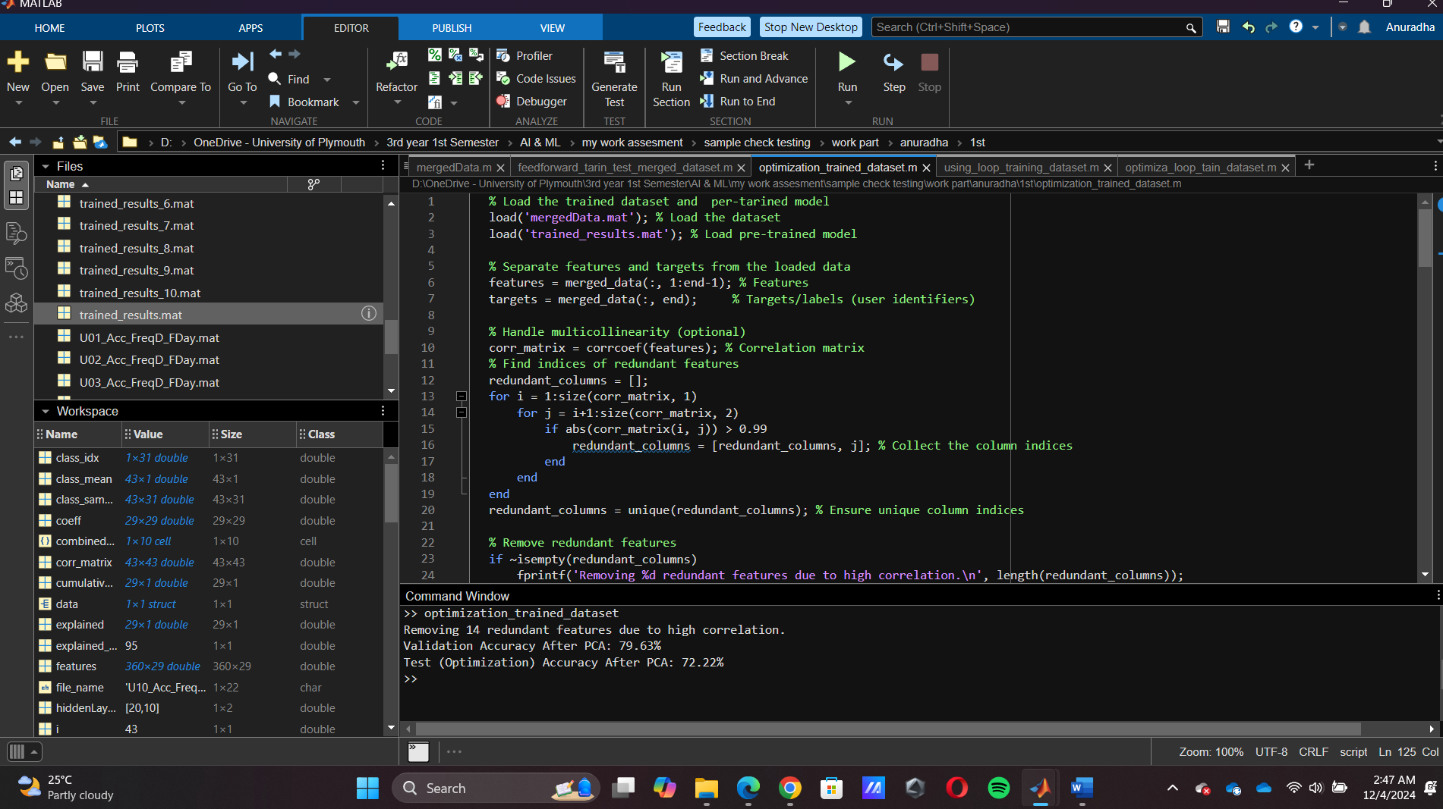

And give the many result and I defined the 2 hidden layers and 20 and 10 neurons in that NN module data set



